Two slopes

Two toy cars move along the same straight line.

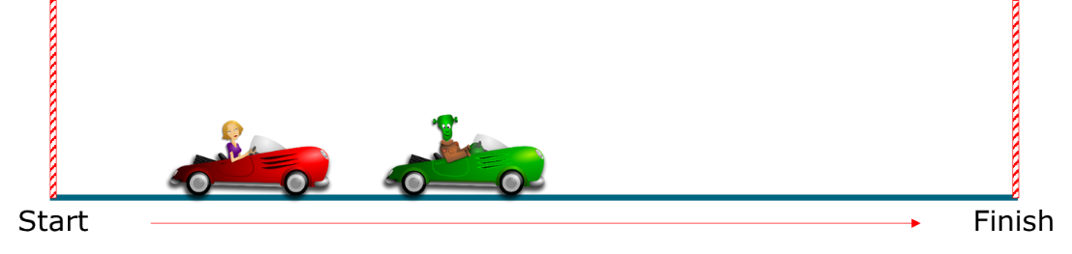

This graph shows a distance - time graph for the two toy cars.

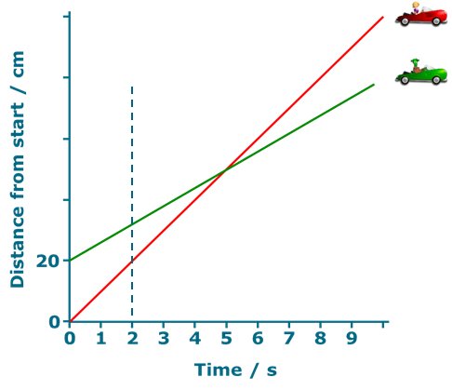
1. At the moment t=2s, which car has a bigger speed?
Put a tick () in the box next to the best answer.
A | Red car
B | Green car

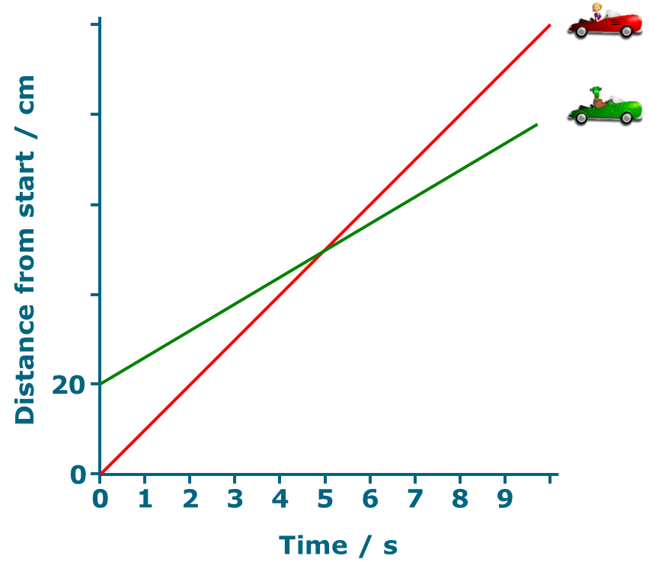
ypos:0.284300in; frame-width:4.176082in; wrap-mode:wrapped-both; frame-height:3.700787in; xpos:1.177143in; frame-type:image
2.

a. Do the cars ever have the same speed?
Put a tick () in the box next to the best answer.
A | Yes
B | No

b. What is the best reason for your last answer?
Put a tick () in the box next to the best answer.

A | The red car goes further
B | The red line is always steeper
C | The lines cross at 5 seconds

Physics > Big idea PFM: Forces and motion > Topic PFM2: Moving by force > Key concept PFM2.2: Motion graphs
Diagnostic question
Two slopes

Overview
Learning focus: | Information about the motion of an object can be summarised on a distance-time graph: the plot shows the object’s distance from the start at a given time and the slope (gradient) at that point shows its speed.
Observable learning outcome: | Describe motion of an object represented by straight lines on a distance-time graph.
Question type: | Two-tier multiple choice
Key words: | Distance, time, graph

What does the research say?
It is common for students to view motion graphs as pictures that link to existing physical knowledge of a situation. (Lingefjard and Farahani, 2018; Stump, 1999; Brasell, 1987; Clement, 1986) For example Clement (1986) found that 28% of 12- to 14-year-olds (n=25) drew an up-hills and down-hills picture of a cycle route when asked to draw a speed-distance graph. Likewise Lingefjard and Farahani (2018) found that 35% of 18-year-olds (n=17) interpreted distance-time graphs intuitively as if they were pictures.
Often text books (and teachers) put great attention on the procedures for plotting graphs and calculating gradients, rather than developing understanding of relationships that a graph shows (Stump, 1999). It can be more constructive to concentrate on the latter, which involves teaching:
- understanding of how to read information directly from a graph, interpreting each axis individually
- how to describe simple relationships between the axes such as those represented by straight lines
- how to interpret a graph, linking what it represents to a real situation (Friel, Curcio and Bright, 2001; Lingefjard and Farahani, 2018)
This question investigates students’ understanding of how straight lines on distance-time graphs represent the speed of objects in real situations.
Ways to use this question
Students should complete the questions individually. This could be a pencil and paper exercise, or you could use an electronic ‘voting system’ or mini white boards and the PowerPoint presentation. The follow on question will give you insights into how they are thinking and highlight specific misunderstandings that some may hold.
If there is a range of answers, you may choose to respond through structured class discussion. Ask one student to explain why they gave the answer they did; ask another student to explain why they agree with them; ask another to explain why they disagree, and so on. This sort of discussion gives students the opportunity to explore their thinking and for you to really understand their learning needs.
Differentiation
You may choose to read the questions to the class, so that everyone can focus on the science. In some situations it may be more appropriate for a teaching assistant to read for one or two students.
Expected answers
1. A: Red car
2a. B: No 2b. B: The red line is always steeper
How to respond - what next?
Many students appear to need assistance in learning how to choose between height or slope of a graph when answering questions about the topic represented by the graph (McDermott, Rosenquist and van Zee, 1987).
In question 1, at 2s it is clear that the slope of the red line is steeper and the distance it travels increases more in each second, but many students do not give the correct response. They often focus on the difference in height to determine which car has the greatest speed.
For question 2 the slope of the line representing the red car is always steeper that that representing the green car. Most students who answer this question incorrectly choose answer C, because the lines coincide.
If students have misunderstandings about which feature of the graph to concentrate on in answering questions about the topic represented by the graph, it can help to describe each line separately using the axes to work out together how many centimetres each car travels in one second.
Another strategy to develop understanding of which features represent different types of movement is to use motion sensors and data-loggers to plot real-time graphs of motion. Students can practise predicting the shape of graph for different descriptions of motion and also reproduce the shape of given graphs by moving in front of a motion sensor. The following BEST ‘response activity’ could be used to do this in follow-up to this diagnostic question:
- Response activity: Speedy graphs
Acknowledgments
Developed by Peter Fairhurst (UYSEG), from an idea by McDermott, Rosenquist and van Zee (1987).
Images: Peter Fairhurst (UYSEG); red car: https://pixabay.com/en/automobile-woman-blond-car-driver-160339/; green car: https://pixabay.com/en/frankenstein-halloween-automobile-160358/.
References
Brasell, H. (1987). The effect of real-time laboratory graphing on learning graphic representations of distance and velocity. Journal of Research in Science Teaching, 24(4), 385-395.
Clement, J. (1986). Adolescents' Graphing Skills: A Descriptive Analysis. Cambridge, Mass.: Technical Education Research Center.
Friel, S. N., Curcio, F. R. and Bright, G. W. (2001). Making Sense of Graphs: Critical Factors Influencing Comprehension and Instructional Implications. Journal for Research in Mathematics Education, 32(2), 124-158.
Lingefjard, T. and Farahani, D. (2018). The Elusive Slope. International Journal of Science and Mathematics Education, 16, 1187-1206.
McDermott, L. C., Rosenquist, M. L. and van Zee, E. H. (1987). Student difficulties in connecting graphs and physics: Examples from kinematics. American Journal of Physics, 55, 503-513.
Stump, S. (1999). Secondary Mathematics Teachers' Knowledge of Slope. Mathematics Education Research Journal, 11(2), 124-144.

